HD 136925

HD 136925 is a 0.875 M☉, G0 star1. Based on 53 RV HIRES measurements obtained between 1998 and 2020, the CL survey reported a LPGP with a period of days, a minimum mass of MJup and an eccentricity of .

In the present study, the CL survey's dataset was used. DPASS and MCMC (1000 walkers and 300000 iterations) were used to fit the data. The properties found for HD 136925b reported in the CL survey were within the error bars associated with the values found in the present analysis.

The fits are shown in Fig 1, and the corner plot in Fig 2, and the results summarized in Table 1.

Conclusion: The properties found in the CL survey for HD 136925b are confirmed.

Figure 1: Left: fit of the HD 136925 RV with DPASS. Red - Hir94, green - Hir04. The blue curve shows the best fit. Right: fit of the HD 136925 RV using MCMC. The black curve shows the best fit. The colorbar corresponds to the log-likelihood of the fits.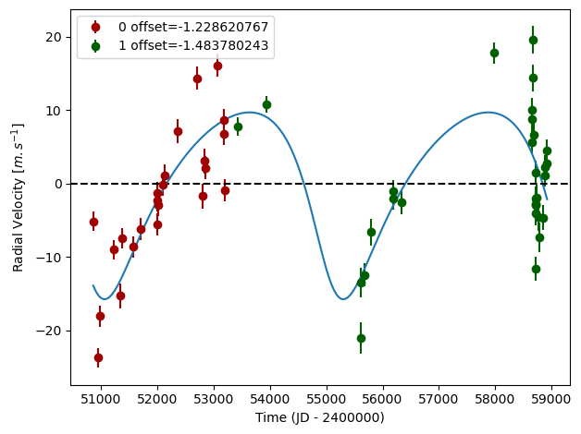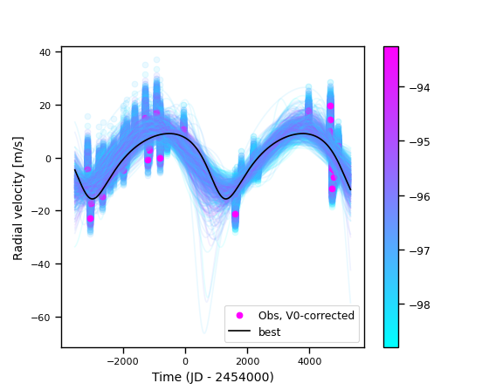

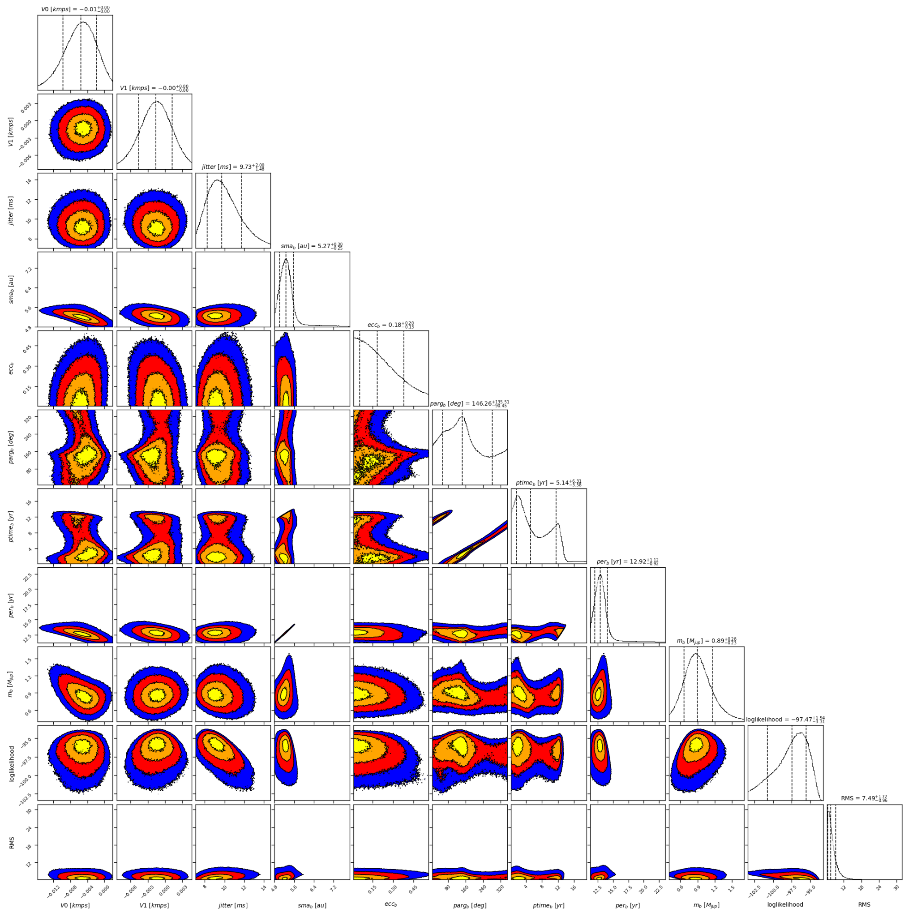

Figure 2: Corner plot of posteriors for the one-planet model MCMC fit of HD 136925 RV data.

| Parameter | Priors | | Posteriors | | CL survey |
| --- | --- | --- | --- | --- | --- |
|  | DPASS | MCMC | DPASS | MCMC |  |
| *a* (au) | [0,100] | [2,10] | 4.9 | 5.3 ± 0.3 |  |
| Msin(i) (MJup) | [0,100] | [0.5,10] | 0.89 |  |  |
| Eccentricity | [0,0.95] | [0,0.9] | 0.28 | < 0.38 |  |
| Instrumentals offsets (km/s) | [-60,60] | [-1,1] | Hir94: -0.001  Hir04: -0.002 | Hir94: -0.006 ± 0.004  Hir04: -0.002 ± 0.003 |  |
| Stellar jitter (m/s) | [0,40] | [0,20] | 8 |  |  |
| Argument of periastron (°) | [0,360] | [0,360] | 145 | 56 – 282 |  |
| Phase | [0,1] | [0,1] | 0.99 | 0.12 – 0.85 |  |

Table 1: HD 136925. Summary of priors and posteriors obtained with DPASS and MCMC, compared to the properties reported by the CL Survey.

References

1. Rosenthal, L. et al. The California Legacy Survey. I. A Catalog of 178 Planets from Precision Radial Velocity Monitoring of 719 Nearby Stars over Three Decades. *Astrophys. J.* *Suppl. Ser.* 255, 8 (2021).